Assignment 3.3 Contemporary Art

Question | Artwork 1- Campbell’s Soup Cans | Artwork 2- Venus of Willendorf
Subject Matter | The artwork shows 32 cans of Campbell’s soup. Each can represent a different soup flavor. The artwork focuses on an ordinary consumer product. | The sculpture is a small female figure with an exaggerated body, including large breasts, stomach and hips. Her face is not clearly shown.
Medium | Synthetic polymer paint and graphite on canvas. | Limestone, carved by hand.
Elements & Principles of Design | Repetition is one of the most noticeable principles because the soup cans are repeated across the artwork. The strong red and white colors create contrast and make the cans easy to recognize. The repeated shapes also create unity. | The rounded shapes and exaggerated proportions immediately catch attention. The sculpture has strong texture and three-dimensional form. Its small scale also makes it interesting because it is an object that could have been carved by hand.
Year and Place | 1962, United States | 25,000-30,000 BCE, Austria
Social, political or spiritual ideas | The artwork represents the growing importance of consumer culture, advertising, mass production, and popular products in American society. | The sculpture is often connected to ideas about fertility, motherhood, survival, and the human body. However, its exact purpose is unknown, so these interpretations are not certain.
Moral values represented | It can represent the value placed on everyday life and popular culture. It also makes viewers think about consumerism and how advertising influences people. | It may represent the importance of fertility, reproduction, survival and the human body. It may have had a spiritual or symbolic purpose, although historians cannot know for certain.
Insert Image here | 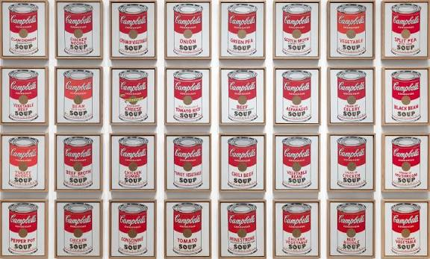 | 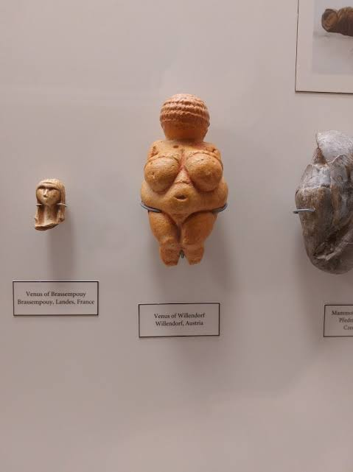

Question | Artwork 1- Campbell’s Soup Cans | Artwork 2- Venus of Willendorf | VIDEO- Unboxing/Packing
Subject Matter | Campbell’s Soup Cans and consumer products. | A prehistoric female figure. | The video focuses on opening products and showing the objects to an online audience. The main subject is the product and experience of presenting. It.
Medium | Synthetic polymer paint. | Carved limestone sculpture. | A YouTube video using digital video, sound, editing and, a social-media platform.
Elements & Principles of Design | Repetition, color, contrast, balance, and unity. | Shape, texture, volume, proportion, and three-dimensional form stand out. | Color movement, close-up views, texture, sound, and repetition catch the viewer’s attention.
Year and Place | 1962, United States | 25,000-30,000 BCE, Austria | Would depend on the specific short selected.
Social, political or spiritual ideas | Represents consumer culture, advertising, mass production, and the growing influence. | May represent, fertility production, motherhood, or survival. | Represents modern cosumer culture, online shopping, social media, advertising, and the desire to share products and experiences with other people.
Moral values represented | It can encourage viewers to think about consumerism. | It may represent fertility, survival, and the importance of reproduction. | The video can represent excitement, sharing, curiosity, and appreciation for products. It can also show how social media encourages people to consume and display products.
Insert Image here | IMAGE | IMAGE | LINK

What has changed?  (Medium, values, ideas, subject matter) | A lot has changed in art over thousands of years, especially the mediums artist’s use. The Venus of Willendorf was carved from stone, while Andy Warhol used paint and canvas. Today, people can use digital video and social media to create visual content that can reach millions of people. The technology has changed the way people create and experience visual culture.
What stayed the same?  (Medium, values, ideas, subject matter) | Even though the mediums and subjects have changed, some things have stayed the same. People have always used visual images to communicate ideas and values. The prehistoric artist used the shape and proportions of the figure to communicate something important, while Warhol used color, repetition, and recognizable imagery.

